Title or Task: |   

Description:

Files Required
Suitable for Classes: | AIT • Multimedia • Cert II IT • Cert II Bus
Area: | Technology & Enterprise
Teacher: | Mr Peter Faulks

Timeline

Date Due:
Task Brief: | In class lesson

Outcomes:

Items highlighted in yellow are tasks for you to complete
Items in Blue italics are help tips

These pages are designed to show you how to use software packages; various software updates may have taken place so some pages will not apply to versions other than those listed here. In some cases data files may be required.

Create an invitation to Annual Y11 Ball on 30th of November at the Royal Fremantle Yacht Club (Do NOT duplicate the one below – make your own flyer)

The school needs to issue a notice to parents providing information about the ball. (Create a notice that includes the following menu in a professionally laid out format):-
Soup of the Day Served with Crusty Roll,
Beef With Sweet Peppers, Mange Tout and Oyster Sauce with Steamed Rice, or
Chicken Glorioso, with Alfredo sauce, artichokes and sun-dried tomatoes
Or
Chicken Caesar Salad,
Sticky Toffee Pudding
or
White Chocolate Cheesecake

Your task is to create a simple database (Excel) and use the mail merge capabilities of your software to produce a letter as close as possible to the one included below:

You will need to print three letters, a copy of the form letter showing only the placeholders and a copy of your database.

Make sure each printout includes a header with your name and a footer with the page number.

Create a Data file of names in Excel using the following list

Mr & Mrs | Barrett | 1 Goerge Street | Murdoch | 6156
Mr & Mrs | Edwards | 1 Harber Dve | Murdoch | 6156
Mr & Mrs | Chapple | 1 Henley Place | Armadale | 6155
Mr & Mrs | Pillay | 1 Hickey St | Applecross | 6153
Mr & Mrs | Manderitt | 1 Kosak Crt | Murdoch | 6156
Mr & Mrs | Cammarano | 1 Matheson Road | Bateman | 6153
Mr & Mrs | Martin | 1 Moreing Rd | Canning | 6164
Mr & Mrs | Craggs | 1 Power Place | Murdoch | 6156
Mr & Mrs | Miveherton | 1 River Way | Applecross | 6153
Mr & Mrs | Lucas | 1/11 Mcleod Road | Murdoch | 6156
Mr & Mrs | Viner | 1/159 Stock Road | Murdoch | 6156
Mr & Mrs | Matthews | 1/29 Seventh Rd | Murdoch | 6156
Mr & Mrs | Jones | 1/77 Kintail Road | Applecross | 6153
Mr & Mrs | Marchioli | 1/80 Swan Rd | Alfred Cove | 6154
Annual Year 11 Ball
on
30th of November
at the
Royal Fremantle Yacht Club
7:30 for 8:00 pm
Picture or school logo here

8 November, 2007

Data merge here
Data merge here
Data merge here
Data merge here

Dear Data merge here,

You are cordially invited to attend the above……..(you add information)

Dress is semi-formal, cocktails at 7:30 Main Course at 8:15pm

Please RSVP or advise me by November 15th Phone: on 9876 5432 or fax 9876 5422 or to my email:
yourname@corpus.edu.wa.au if you wish to attend….

Yours faithfully,

Your name
Student Organiser

Task 11.02 Mail Merge

Open invitation.doc

Using the Business letter/invitation created in Task 7 mail merge with the database created in Task 3.1.

As you would be using window envelopes the names and addresses should be under your letterhead in the top left hand corner.

Print the 6 invitations on either of the Forrest Flower Shop, Bateman Couriers, Murdoch Multimedia and Winthrop Events Management letterhead, which must include footer comprising your name, together with the date and time of printing.
HOW TO MERGE DATA

Copy your letter to a new page click on Tools Letters & Mailing Mail Merge

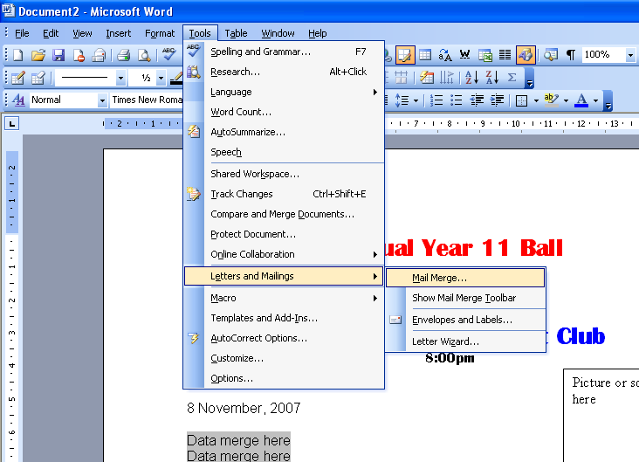

Select Letters Click on select recipients Click on Browse
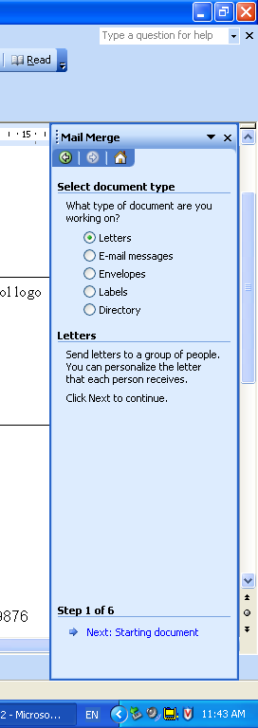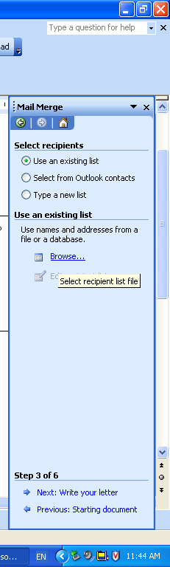
Click on Browse and find balldata.xls
open this data file
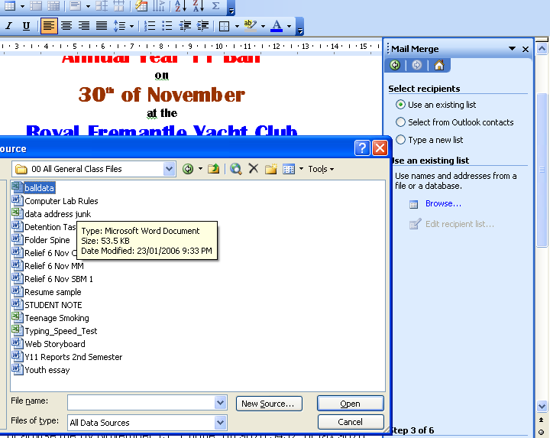

The database should contain only five records and you will need to include names, addresses and any other data you feel is relevant for the production of the letter.

A sample is shown here: save your data a file as ball data.xls
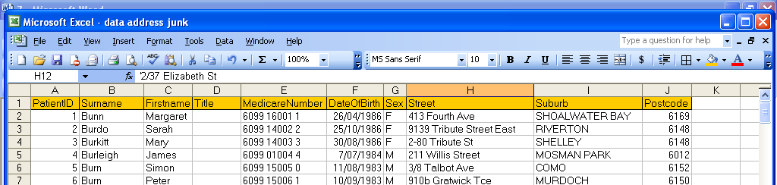

Click O.K. to select your data file then O.K. to accept the data fields

You will need to open the Mail Merge Toolbar

Then place the cursor where you want a data field
select each field and place it on your document

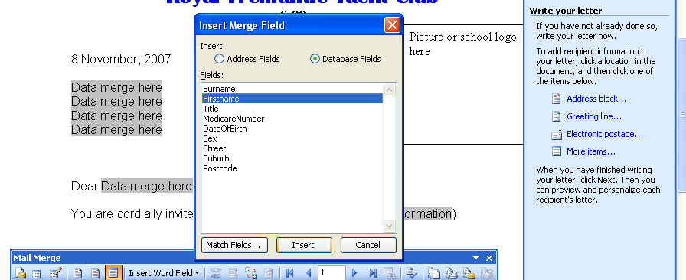

Select the field this will replace the data text
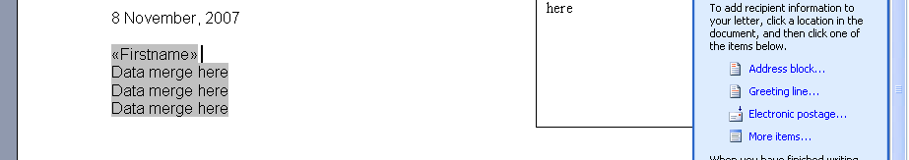

Go to preview and print ONLY three Pages

You will need to print three letters, a copy of the form letter showing only the placeholders and a copy of your database.

Make sure each printout includes a header with your name and a footer with the page number.

Save the work



